Arunkumar K (73152113010)

Email: [arunvikram23@gmail.com](mailto:arunvikram23@gmail.com)

1. create one .txt file, five .c files and five .java files in the working area.
2. Verify the git status

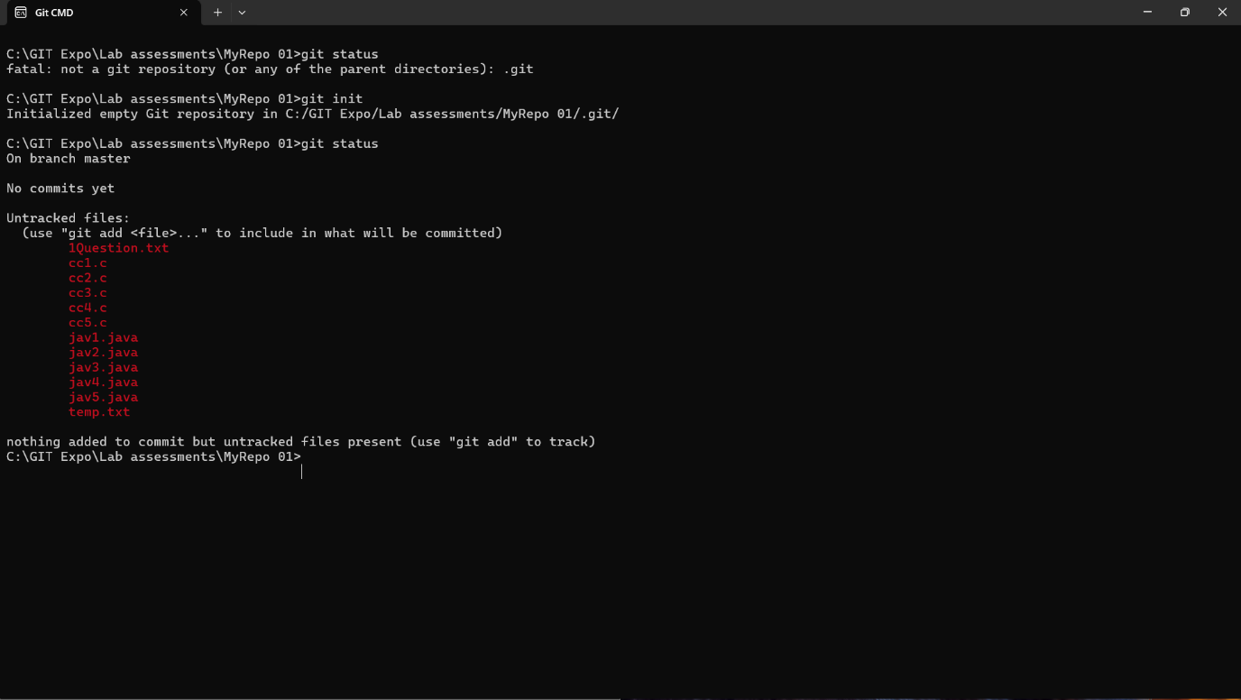

1. Add only the .txt into the staging area

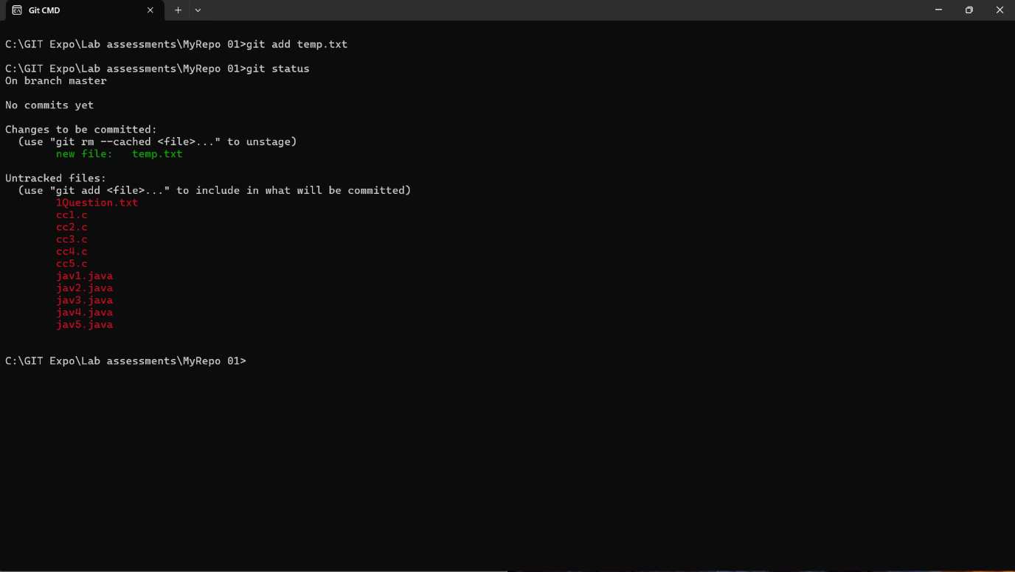

1. Add only the .txt into the staging area

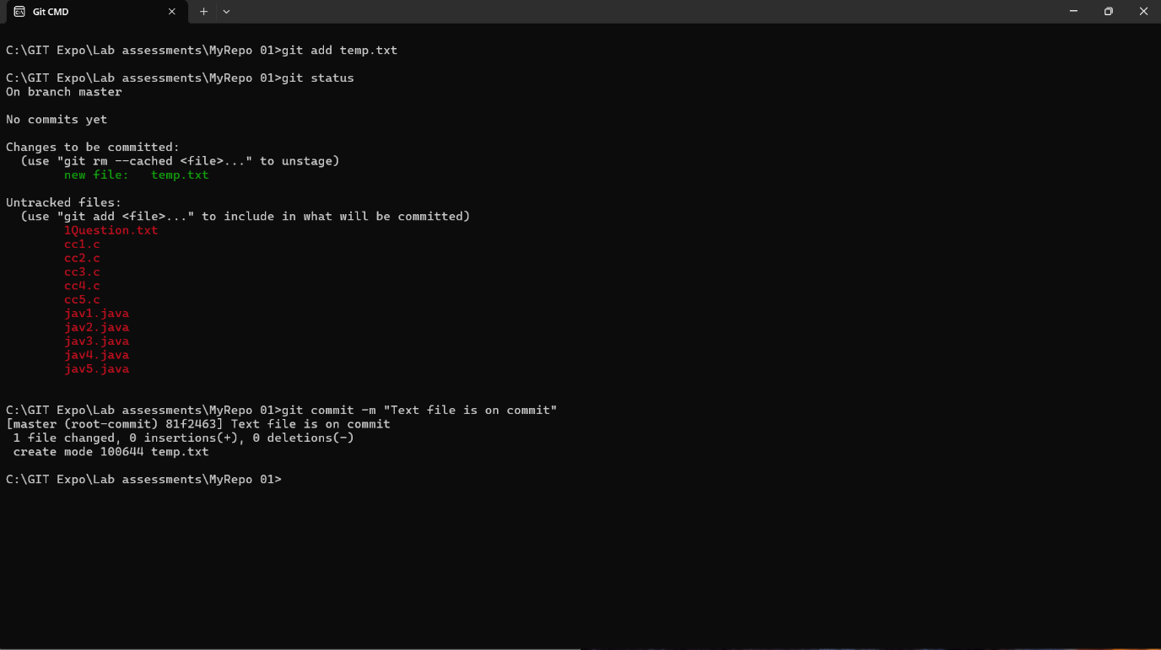

1. verify the git status

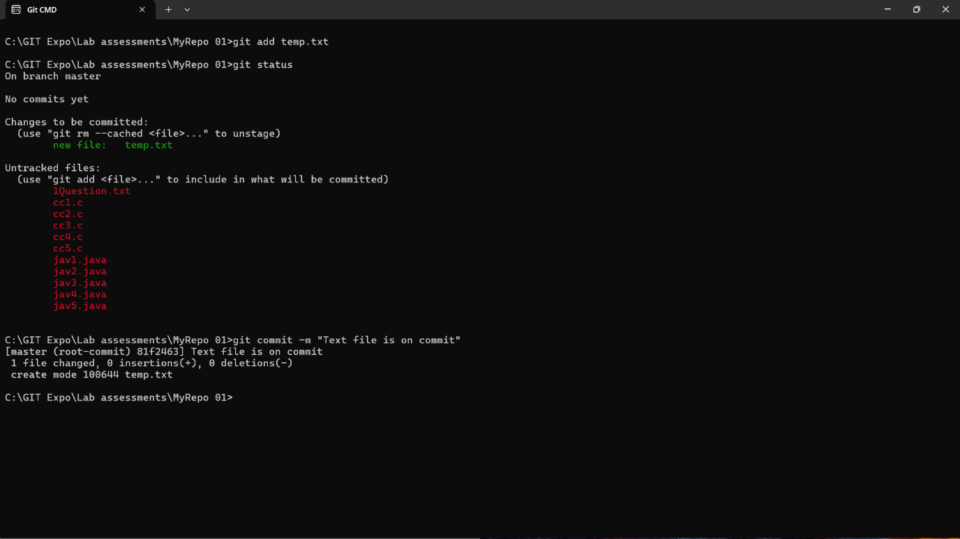

6.Make a commit with the name "TXT Commit"



7. Add all .c files into the staging area and verify status.

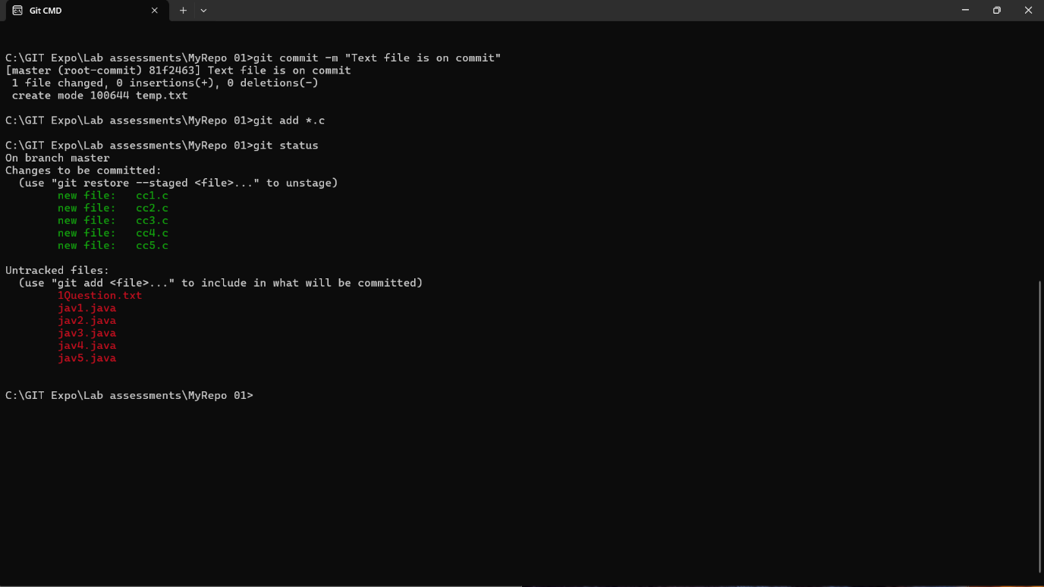

8. Make a commit with the name "C Commit"

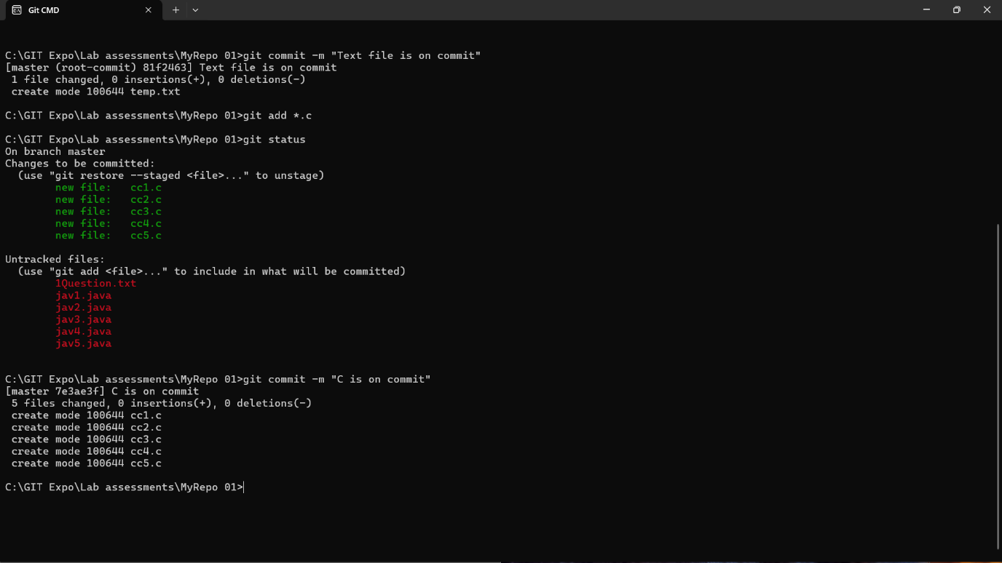

9. Add all .java files into the staging area and verify the status

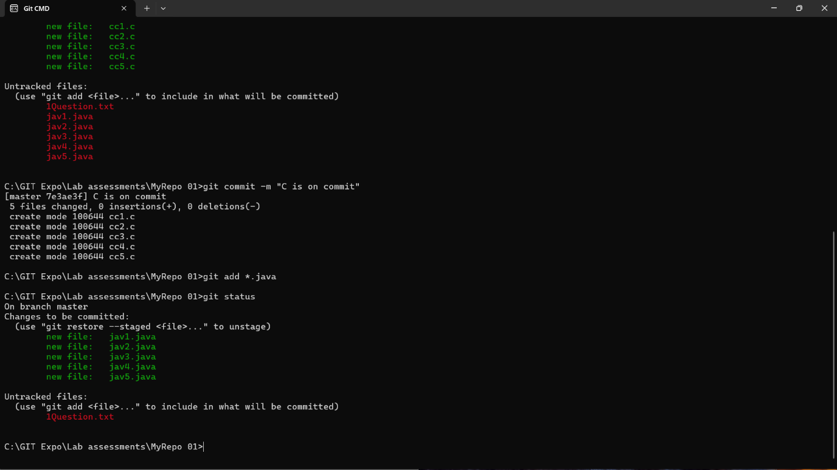

10. Make a commit with the name "Java Commit"

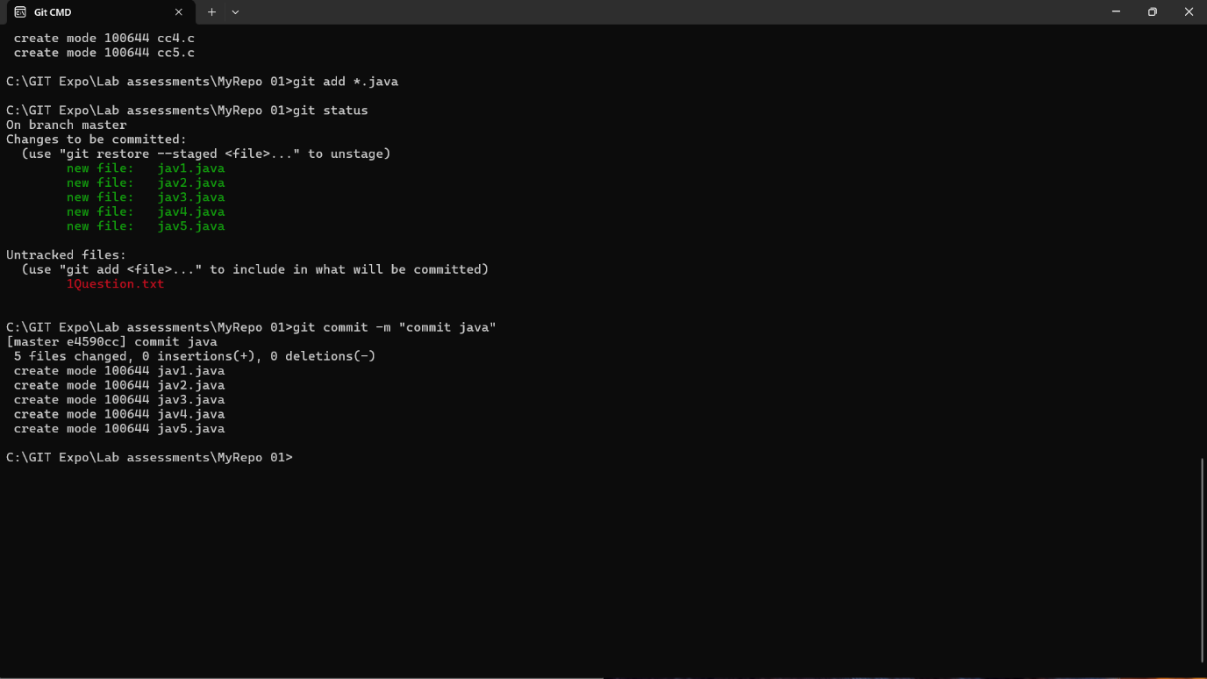

11. Delete all .java files from working area

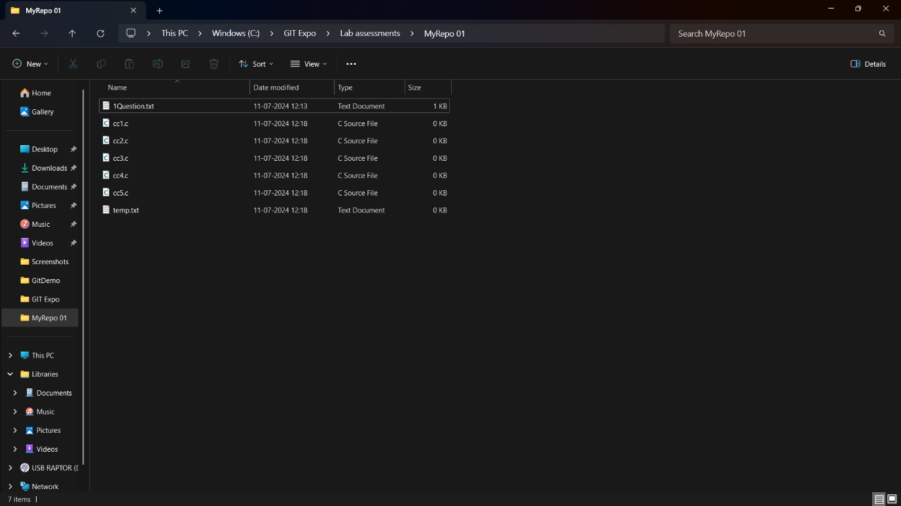

12. Now see the status

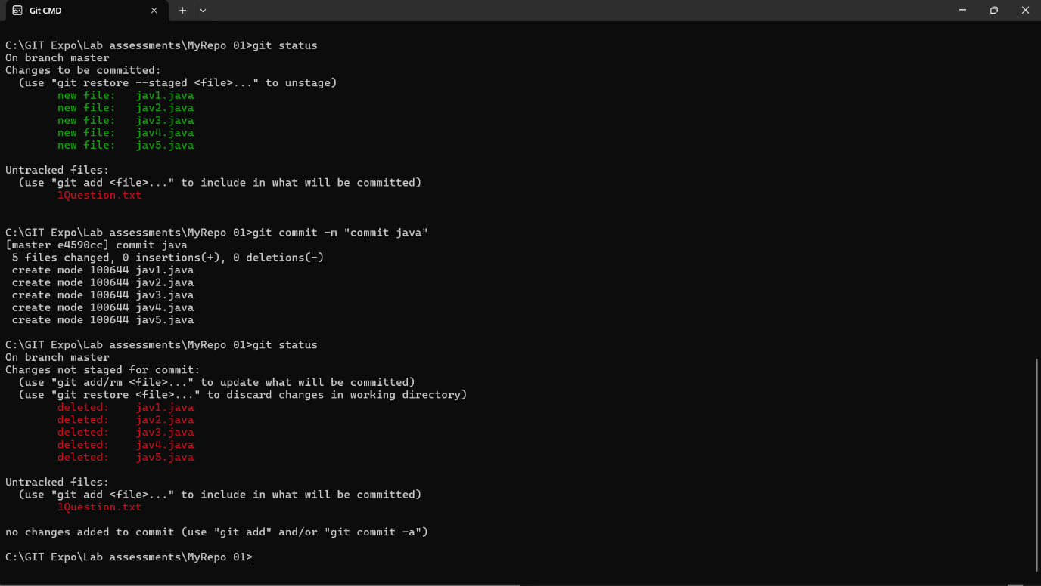

13. add the changes into the staging area and Make a commit with the name "Delete Java Commit" .

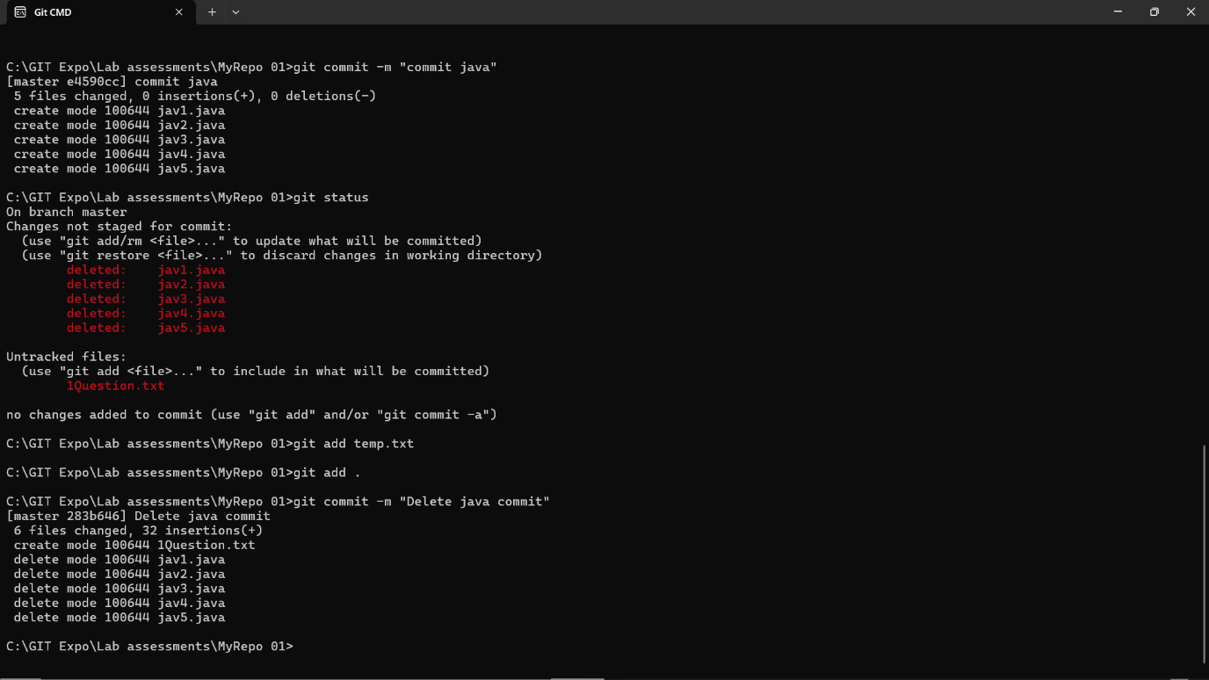

14. Display all commit details

